
Table of Contents

1.0 Introduction 01
1.1 Purpose of the document 01
1.2 Definitions and Acronyms 01
1.3 Project Overview 01
1.4 In Scope 01
1.5 Intended Audience 02
1.6 Constraints, Assumptions and Dependencies 02
2.0 Use Cases 02
2.1 Admin Home Page 03
2.2 Admin Login Page 04
2.3 New Admin Register Page 04
2.4 Creator Register Page 05
2.5 Creator_List Page 06
2.6 Admin_list Page 07
2.7 learner Register Page 07
2.8 Learner Login Page 08
2.9 Learner Login Page 08
2.10 Contents Details page 09
2.11 Creator Login Page 10

Introduction

Purpose of this document
The purpose of this document is to define the use cases for E-Learning Platform.

Definitions & Acronyms
Definition / Acronym | Description
ELP | E-Learning Platform

Project Overview
Online E-Learning Platform is a system which maintain the information about learning contents present in application, their creator categories of contents etc. It also allows the creators to add their contents and find relevant audience for it. It is designed to be user friendly and creator friendly functionalities to be performed.
This platform can offer the learner to select their interests of topics and can get the contents according to it.

In Scope
Following are the key features that needs to be implemented for Customer and Admin:
Learner
- Views contents
- Select their category of interests
- Deselect their categories of interests
Admin
- Register Creators
- View Creators details
- Register new Admins
- View Learners Details
Creator
1. Add contents

Intended Audience
- Product Owner
- Scrum Master
- Application Architect
- Project Manager
- Test Manager
- Development Team
- Testing Team

Constraints, Assumptions and Dependencies
Assumptions
None

Dependencies
None

Constraints
None

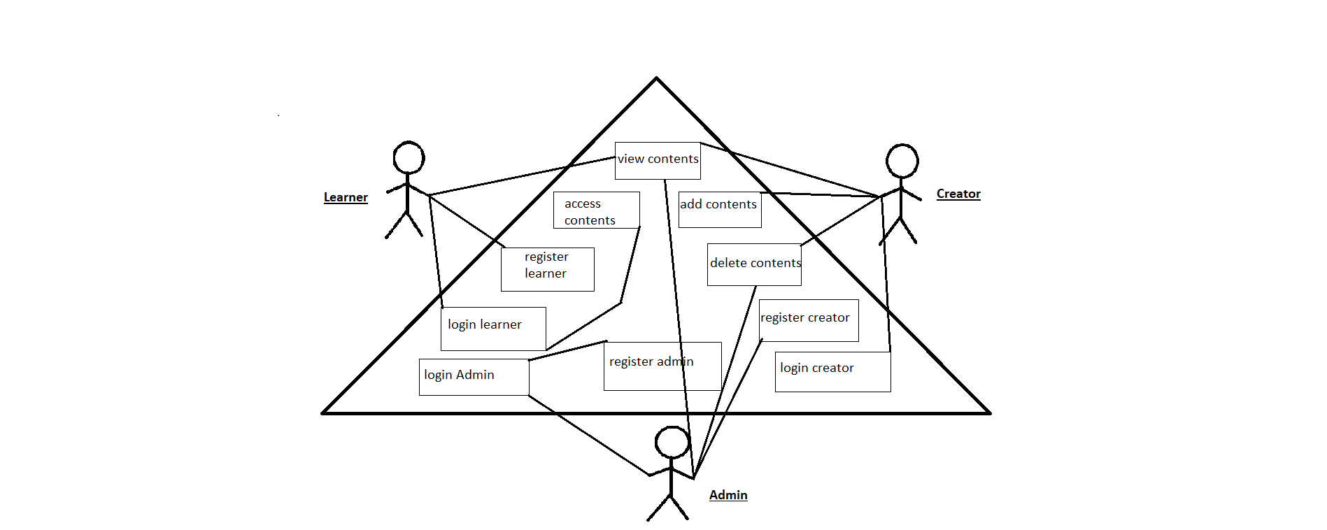

Use Cases
There will be two types of users whom will be using this application:
- Admin
- Learner
- Creator
Admin – Responsible for management of the contents in the platform.
Learner– Learners find contents available to their selected topics can view.
Creators – Add their contents according to the relevant topics.
Find below the list of use case diagram that represents the list of Use Cases that needs to be incorporated.

2.1 Admin HomePage
Use Case ID | ELP1
Use Case Name | HomePage(ADMIN)
Actor(s) | Admin
Description | Admin has the previllege to view the home page of the Application
Pre-condition | Admin should have privilege to home page application and should access the url of the application Online E-Learning Platform
Post-Condition | Admin can login to the root or existing Admins.
Basic Path | - Admin opens the browser and browses the application url to open the portal Online E-Learning Platform.

2.2 Admin Login Page

Use Case ID | ELP2
Use Case Name | Login Page of Admin
Actor(s) | Admin
Description | In this page Admin can login with his valid details.
Pre-condition | In this case Admin can view the Home page of this application  Online E-Learning Platform.
Post-Condition | After Login Admin can register other admins and creators with their valid details.  Admin should have the privilege of AdminHome page.
Basic Path | - After Accessing the url of this application Admin can access the Login page of the Application.  - run this query in admin_datails table (insert into admin_details values(1003,'marie_curie','root','root',45678,'marie_curie','root@123');)  use emailId = 'root@123' and password='marie_curie' to login.  - In Home page admin can access the url of the register page by clicking on it.  - After accessing the url Admin can enter the respective details and Logged in to the portal.  - Admin should enter the details like i:  a) Admin Id  b) password

New Admin Register Page

Use Case ID | ELP3
Use Case Name | New Admin Register Page
Actor(s) | Admin
Description | Admin can register other admin by providing valid details.
Pre-condition | Admin should have privilege to login.
Post-Condition | After successful Register other admin can also logged in to the portal.
Basic Path | - Admin after successful registration of his details can access the login page.  - In the login page admin should enter login details like:  a)Email Address  b)Password  3. After entering the valid details it leads to successful login.  Otherwise, Enter the valid details to login.

2.4 Creator Register Page

Use Case ID | ELP4
Use Case Name | Creator Register Page
Actor(s) | Admin
Description | Admin register the creator to portal with their valid details.
Pre-condition | Admin should have privilege to login.
Post-Condition | Admin can view all the creators details after adding them successfully
Basic Path | - After successful login in the application admin can access the url “RgisterCreator” to register the creators to portal.  - Creators details are added to the portal like:  a)Creator_Id  b)First Name  c)Last Name  d)Email Address  e)Password  f)Mobile Number  3. The above details of the creators are added to the application in the creator_details table.  - After register the creators can login to the portal.  - After registering admin can also view the creators details.

2.5 Creator_List Page
Use Case ID | EBM5
Use Case Name | Creator_Details page
Actor(s) | Admin
Description | Admin can view all the creators.
Pre-condition | Admin should have the privilege to add register the creator to the application.
Post-Condition | Admin Can update, delete and edit the details of creators also admin can access the contents created by creator_Id .  Admin should have the privilege of Creator_DetailsbyId page
Basic Path | - After registering the creator successfully to the portal or application admin can view the creator details.  - Creator details involves like  a)Creator_Id  b)First Name  c)Last Name  d)Email Address  e)Password  f)Mobile Number  - Admin can view contents of creator by id.

2.6 Admin_list Page

Use Case ID | ELP6
Use Case Name | Admin_list Page
Actor(s) | Admin
Description | Admin should have privilege to view the Admin details .
Pre-condition | Admin should have privilege to AdminHome page.
Post-Condition | Admin can logout from the application and returns to the home page of this application.
Basic Path | - Admin can view the customer cart details.

2.7 Learner_list Page

Use Case ID | ELP7
Use Case Name | Learner_list Page
Actor(s) | Admin
Description | Admin should have privilege to view the Learner details .
Pre-condition | Admin should have privilege to AdminHome page.
Post-Condition | Admin can logout from the application and returns to the home page of this application.
Basic Path | - Admin can view the Learners details and can update , delete it.

2.8 learner Register Page

Use Case ID | ELP8
Use Case Name | Register Page of Learner
Actor(s) | Learner
Description | In this page Learner can register with his valid details.
Pre-condition | In this case Customer can view the Home page of this application Online E-Learning platform.
Post-Condition | After Registration Learner can login through his valid details.
Basic Path | - After Accessing the url of this application Learner can access the Register page of the Application.  - In Home page customer can access the url of the register page by clicking on it.  - After accessing the url Learner can enter the respective details and Register the details.  - Details provided in Register page:  a)Learner Id  b)First Name  c)Last Name  d)Email Address  e)Password  f)Confirm Password  g)Mobile Number

2.9 Learner Login Page

Use Case ID | ELP9
Use Case Name | Learner Login Page
Actor(s) | Learner
Description | Learner can enter the application by using his valid login credentials in the login page.
Pre-condition | Learner should have privilege to register page by entering his details.
Post-Condition | After successful login in the application Learner view the contents in the next page of this application.
Basic Path | - Learner after successful registration of his details can access the login page.  - In the login page learner should enter login details like:  a)Email Address  b)Password  3. After entering the valid details it leads to successful login.  Otherwise, Enter the valid details to login.

2.10 Contents_Details Page

Use Case ID | ELP10
Use Case Name | Contents_Details page
Actor(s) | Learner
Description | Learner can view all the contents.
Pre-condition | Customer should have the privilege to log into the application.
Post-Condition | Customer Can view the contents.
Basic Path | - After login into application customer can view the contents .

2.11 Creator Login Page

Use Case ID | ELP11
Use Case Name | Creator Login Page
Actor(s) | Creator
Description | Creator can enter the application by using his valid login credentials in the login page.
Pre-condition | Creator should already be registered by the admin.
Post-Condition | After successful login in the application Creator can add the contents.
Basic Path | 1. Learner after successful registration of his details can access the login page.  2. In the login page learner should enter login details like:  a)Email Address  b)Password  3. After entering the valid details it leads to successful login.  Otherwise, Enter the valid details to login.

